

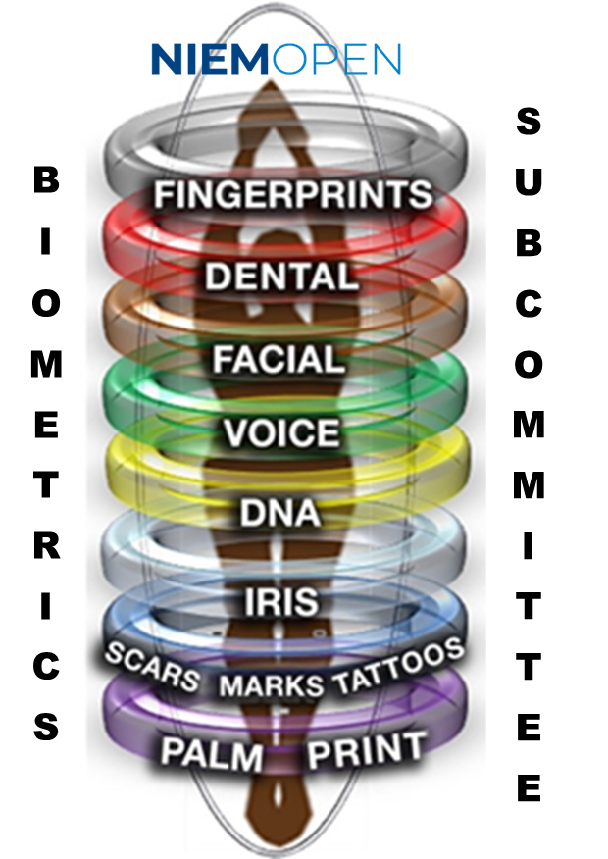

**NIEMOpen Biometrics Sub-Committee (NBS) Governance**

**January 2024**

**Document Change Control Page**

**This document amplifies the Organization for the Advancement of Structured Information Standards (OASIS) Open Project Lightweight Rules,** [NIEMOpen Charter document](https://github.com/niemopen/oasis-open-project)**, and NIEMOpen Business Architecture Committee (**[NBAC) Technical Steering Committee (TSC) Governance Document](https://github.com/niemopen/nbac-admin/tree/main/documents)**. It incorporates all provisions of those documents. In case of conflict, the parent documents control.**

**The Biometrics Sub-Committee Governance is a living document, reviewed periodically, and based on inputs from the Biometrics Sub-Committee Community-of-Interest.**

|  |  |  |  |
| --- | --- | --- | --- |
| **No.** | **Version** | **Date** | **Description** |
| **1** | **V 1.0** | **14 Oct 21** | **Original Charter** |
| **2** | **V 2.0** | **January 26, 2024** | **Rewrite for OASIS transition** |
| **3** |  |  |  |
|  |  |  |  |
|  |  |  |  |
|  |  |  |  |
|  |  |  |  |
|  |  |  |  |

Table of Contents

1. Introduction 4

1.1 Overview 4

1.2 Document Scope 4

1.3 Intended Audience 4

1.4 Reference Documents 4

2. Sub-Committee Overview 4

2.1 Sub-Committee Business Need or Goal 4

2.2 Sub-Committee Scope 5

2.3 Sub-Committee Community of Interest 6

2.4 Sub-Committee Goals 6

2.5 Sub-Committee Responsibilities 7

3. NIEMOpen Governance 7

3.1 Project Governing Board 8

3.2 NIEMOpen Management Office 8

3.3 NIEMOpen Business Architecture Committee (NBAC) 8

3.4 NIEMOpen Technical Architecture Committee (NTAC) 8

4. Sub-Committee Governance Structure 8

4.1 Overall Sub-Committee Governance Structure 8

4.2 Sub-Committee Governance and NBAC TSC Relationship 9

4.3 Sub-Committee Sponsor 9

4.4 Sub-Committee Governance 11

5. Updating Governance 13

6. Acronyms 14

Table of Figures:

Figure 1: NIEMOpen Project Governance 8

Figure 2: Biometrics Sub-Committee Governance Structure 9

# 1. Introduction

### **1.1 Overview**

**The Biometrics Domain within NIEM (National Information Exchange Model) was established in 2012. The Biometrics Domain transitioned to NIEMOpen as the Biometrics Sub-Committee under the auspices of the OASIS Open project in October 2022. The Biometrics Sub-Committee was established to support information sharing and promote interoperability between mission-based organizations engaged in activities such as homeland security, national defense, border management, immigration benefits, and global law enforcement through the joint development and alignment of NIEMOpen Biometric** **Standards.**

**The Biometrics Sub-Committee supports the development of information exchange specifications across a full range of biometrics and identity management in combination with the existing NIEMOpen Core and other Sub-Committees. This Sub-Committee is an aggregation of stakeholders into a community of interest (COI) that is aligned with biometrics and identity management. The Biometrics Sub-Committee serves a dynamic biometrics and identity management user community and seeks effective harmonization of data models among the community to serve the needs of its major stakeholders, including the United States (US) Department of Homeland Security (DHS), the Department of Defense (DOD), and the Department of Justice (DOJ), which form the Biometrics Triad. The Biometrics Sub-Committee is an operational mission focused venue designed to provide multi­functional, cross-organizational data elements that the Biometrics Triad and COI information exchange developers may use in creating NIEMOpen-based information exchanges.**

### 1.2 Document Scope

**This Sub-Committee Governance Document describes the NIEMOpen Business Architecture Committee (NBAC) Technical Steering Committee (TSC) Biometrics Sub-Committee’s (NBS) business focus, scope, and governance structure.**

### 1.3 Intended Audience

The intended audience for this document is the Biometrics Sub-Committee’s stakeholders and governance groups, as well as the NBAC TSC for reference purposes.

### 1.4 Reference Documents

The following is a list of reference documents to assist in the establishment and maintenance of the Biometrics Sub-Committee:

* [OASIS Open Project Lightweight Rules](https://www.oasis-open.org/policies-guidelines/open-projects-process/)
* [NIEMOpen Charter](https://github.com/niemopen/oasis-open-project/blob/main/CHARTER.md)
* [NIEMOpen Business Architecture Committee Technical Steering Committee (NBAC TSC) Governance Document (REV 1)](https://github.com/niemopen/nbac-admin/tree/main/documents)

# 2. Sub-Committee Overview

### 2.1 Sub-Committee Business Need or Goal

The Biometrics Sub-Committee provides and maintains unique **biometrics and identity management operations and mission data components used to define NIEMOpen Message Exchange Packages (MEPs) that satisfies mission critical information sharing requirements within the Biometrics Triad, and/or Federal government agencies, and Mission Partners. The Sub-Committee works towards the alignment of data standards within the Biometrics Triad, aimed at improving the visibility, understandability, accessibility, trust, and interoperability of shared data.**

**The Biometrics Sub-Committee is part of a coordinated global effort to maintain and refine operations focused on security, intelligence, law enforcement, international trade, travel, and immigration by means of identity management and assurance. The Biometrics Sub-Committee provides technical assistance including Information Exchange Package Documentation (IEPDs) review, organizational system, and policy alignment.**

**The NBS goals align with the Sub-Committee scope and parameters outlined in the subsequent section. To be successful in fostering development and harmony within a Sub-Committee, the Sub-Committee must achieve independence, while facilitating Sub-Committee self-service. Sub-Committee independence ensures that there are Sub-Committee specifications and processes that decouple the Sub-Committee from the NIEMOpen Core development timeline. Such decoupling allows Sub-Committees to publish specification updates per Sub-Committee requirements and Sub-Committee-specific timelines rather than per the Core update timelines. It also allows systems owners and developers to move quickly with the latest IEPD materials and tools.**

**The NIEMOpen Biometrics** Sub-Committee **is a unique Sub-Committee within NIEMOpen that is impacted by rapid technological advancement, systems evolution, and quick development cycles. As such, for Sub-Committee independence to be assured, the Biometrics Sub-Committee must maintain an independent schedule of development and lifecycle processes, including schema review and amendment. These releases will be coordinated with NIEMOpen Management Office (NMO) activities and anticipated release schedules to maximize effectiveness and harmonization and to ensure that the content can be added to the NIEMOpen core and posted via** [NIEMOpen.org](https://niemopen.org/) **to benefit the Biometric COI and lend to the NIEMOpen core development.**

**Sub-Committee “Self-service” closely aligns with independence―the Sub-Committee has the authority, autonomy, and capability to maintain its own content development and management, ensuring proactive engagement within the Sub-Committee and benefiting NIEMOpen scalability as Sub-Committees lend to the NIEMOpen Core reach and utility.**

### 2.2 Sub-Committee Scope

**The Biometrics Sub-Committee manages unique identity operations and mission data components used to define NIEMOpen MEPs that satisfy operational mission information sharing requirements among the Biometrics Triad and their Mission Partners. The Sub-Committee governance is led by the NBS Executive Committee (NBSEC), consisting of the Chair, DHS OBIM, two Co-Chairs, DOJ Federal Bureau of Investigation (FBI) and DOD Defense Forensics and Biometrics Agency (DFBA), and the Ombudsman, the National Institute of Standards and Technology (NIST). The NBSEC members are responsible for actively managing and updating their community’s data model, in addition to administering the operations of the Sub-Committee. A NIEM Biometrics Sub-Committee Working Group (NBSWG) addresses technical and business/operational issues and meets on an as needed basis.**

**As the Biometrics Sub-Committee Sponsor, OBIM will manage the Biometrics Sub-Committee in support of the Biometrics COI. OBIM will appoint an OBIM representative as Chair of the Biometrics Sub-Committee’s Management Committee. The Chair will manage the Sub-Committee in support of the Biometrics COI and in conjunction with the NBSEC. They will utilize any associated business or technical committees to support the NMO in the following program related activities that follow:**

* **Creating a technical infrastructure for Sub-Committee management activities, including technical development, testing, review, and deployment of the Biometric contents to the NIEMOpen data model.**

**This results in the following requirements for the Sub-Committee. It shall:**

* **Follow the NIEMOpen High-Level Version Architecture (HLVA), the NIEMOpen Naming and Design Rules (NDR), the NIEMOpen Model Package Description Specification, the NIEMOpen Sub-Committee Update Specification, and other documentation, standards, and guidelines to maintain the Sub-Committee content and participate in cross-Sub-Committee harmonization activities.**
* **Recommend new NIEMOpen Core components supporting the Biometrics Sub-Committee.**
* **Manage, harmonize, and reuse NIEMOpen components across the Biometrics Sub-Committee community.**
* **Develop, recommend, and implement processes to ensure that the Biometrics Sub-Committee meets the NIEMOpen conformance requirements, as outlined in the** [NIEMOpen Conformance specification](http://niem.github.io/reference/specifications/conformance/)**.**
* **Expand the scope of the Biometrics Sub-Committee to incorporate additional data elements to reflect the evolution and expansion of Biometrics Sub-Committee requirements and new modalities as defined by the COI.**
* **Track technical issues and requirements to ensure their timely resolution, and as required, incorporation in NIEMOpen releases, documentation, communications and training, tools, etc.**

### 2.3 Sub-Committee Community of Interest

**The Biometrics Sub-Committee is sponsored by the DHS OBIM, but it is not a "DHS-unique" organization. It is part of NIEMOpen, with participants from the Federal, State, Local, Tribal, International, and Private organizations.**

### 2.4 Sub-Committee Goals

* Promote Biometrics information sharing between Federal, state, local, tribal, industry and international agencies by contributing harmonized Biometrics content to the NIEMOpen data model and using the NIEMOpen Biometrics data model whenever appropriate
* Identify performance metric(s) for tracking the impact that results from the coordinated efforts of the Biometrics Sub-Committee

### 2.5 Sub-Committee Responsibilities

The NBS is responsible for representing the interests of Biometrics stakeholders within the broader NIEMOpen Community, managing the NIEM NBS model content, conducting sub-committee meetings, and leading the overall activities and administration of the Biometrics Sub-Committee. This includes:

* Biometrics appointment of Sub-Committee Executive Committee, which requires the endorsement of the NIEMOpen Business Architecture Committee Technical Steering Committee (NBAC TSC).
* Sub-Committee Executive Committee is responsible for the governance, management, operations, and model content including maintenance of their unique code-list (s).
* Biometrics Sub-Committee Executive Committee Members’ Individual – Contributor License Agreements (CLA) (Individual - CLAs and Entity - License Agreements (E-CLAs) must be registered before new model content can be contributed by the SC or SC harmonization decisions can be made by SC members. If no Sub-Committee member has executed I-CLAs and E-CLAs as appropriate, the NBAC TSC chair/co-chairs may act on their behalf as conservator until their CLAs are in place.
* An I-CLA exception exists using the mailing list (<https://lists.oasis-open-projects.org/g/niemopen-contributions>) process for occasional content contributors who are not significantly engaged with the project. This alternative is not intended as a routine adjunct to signing CLAs and does not suffice or bestow an I-CLA to the contributor should they later want to contribute work to the project.[1]
* Biometrics Sub-Committee shall hold open meetings for all interested parties, with meeting details sent ahead of time to the [NBAC TSC subgroup mailing list](https://lists.oasis-open-projects.org/g/niemopen-nbactsc).
* Biometrics Sub-Committee shall appoint model content contributors and harmonization representatives that act on behalf of the Sub-Committee
* Biometrics Sub-Committee Chair shall notify the NBAC TSC for posting to the NBAC TSC roster the appointment of:
  + Biometrics Sub-Committee Executive Committee
  + Biometrics Sub-Committee NBAC TSC Harmonization Sub-Committee representatives/contributors
  + Biometrics Sub-Committee NBAC TSC voting member(s)

# 3. NIEMOpen Governance

NIEMOpen, an OASIS Open Project is committed to building an open, inclusive, productive, and self-governing open-source community. The community is governed by the [NIEMOpen Governance Charter](https://github.com/niemopen/oasis-open-project/blob/main/CHARTER.md) and in accordance with OASIS Open Project Rules with the goal of defining how community should work together to achieve their goals.

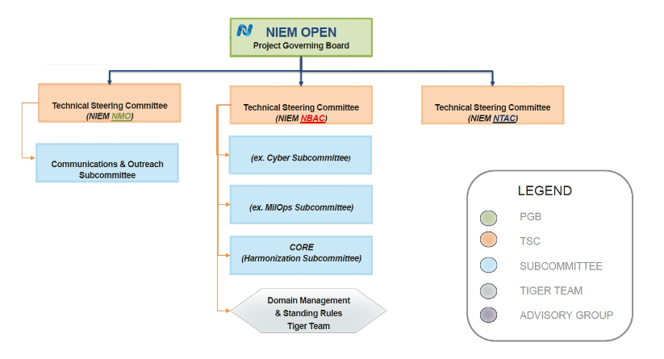

Figure : NIEMOpen Project Governance

### 3.1 Project Governing Board

The group responsible for the overall lifecycle or business strategy of NIEMOpen. Oversees activities such as events, marketing, partnerships, promotion, budget, and so forth.

### 3.2 NIEMOpen Management Office

A Technical Steering Committee that executes the PGB’s vision while supporting core operations and strategy.

### 3.3 NIEMOpen Business Architecture Committee (NBAC)

A Technical Steering Committee that provides oversight of the NIEMOpen core and ensures the data model is understood across all Sub-Committees.

### 3.4 NIEMOpen Technical Architecture Committee (NTAC)

A Technical Steering Committee that documents, implements, and maintains technical specifications for NIEMOpen.

# 4. Sub-Committee Governance Structure

The Biometrics Sub-Committee’s organizational structure, including the member roles designated to carry-out all governance activities, is described below.

### 4.1 Overall Sub-Committee Governance Structure

The Biometrics Sub-Committee must always have a chair or co-chairs. The Biometrics Sub-Committee chair or co-chairs are nominated by the Biometrics Sub-Committee Executive Committee (NBSEC). Biometrics Sub-Committee observers may be admitted to any meeting at the discretion of the Biometrics Sub-Committee chairs.

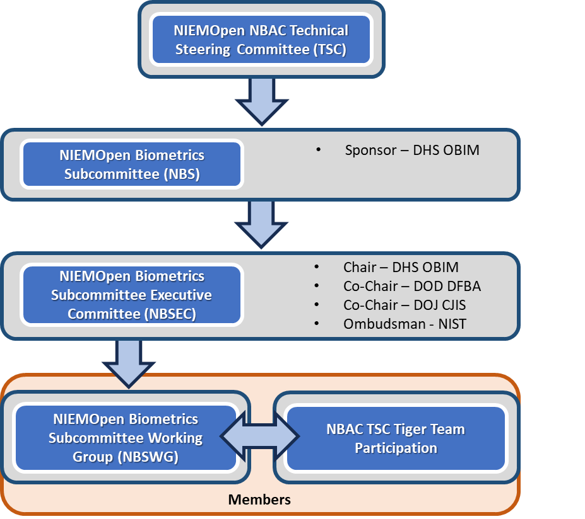

Figure : Biometrics Sub-Committee Governance Structure

### 4.2 Sub-Committee Governance and NBAC TSC Relationship

The NIEMOpen Business Architecture Committee Technical Steering Committee (NBAC TSC) is the central authority in a federated governance model where NBAC TSC will interact with Sub-Committee governance groups, providing coordination, policy and technical direction while allowing each Sub-Committee governance group to retain relative autonomy in governing its Sub-Committee while interacting directly with its own community of interest (COI). Any disputes between the NBAC TSC authority and its Sub-Committees are elevated to the NIEMOpen Project Governing Board (PGB).

### 4.3 Sub-Committee Sponsor

DHS OBIM was the NIEM Biometrics Domain Steward, pursuant to the NIEM Domain Stewardship Agreement (DSA) signed in March 2012 by OBIM and the NMO. The transition to NIEMOpen aligns the Stewardship to the Sub-Committee Sponsor.

The Sub-Committee Sponsor responsibilities include strategic Sub-Committee planning initiatives in concert the NBSEC and the COI, as well as operational and tactical activities that facilitate daily and ongoing operations.

#### 4.3.1 Sub-Committee Executive Committee Responsibilities

The Biometrics Sub-Committee Chair is appointed by the Sub-Committee Sponsor. If the Chair resigns from the position, the Sub-Committee Sponsor shall appoint a new chair.

The Sub-Committee Sponsor shall be a Government employee in the organization of the Sub-Committee Sponsor. The functions of the Chair are:

* Call and lead quarterly meetings of the NBSEC to review governance and Sub-Committee changes/upgrades to the NIEM model.
* Review current development and update projects undertaken on or by the Sub-Committee for timeliness, accuracy and efficiency, while ensuring that any proposed modifications or updates to the biometrics Sub-Committee reflects the wishes of the COI
* Vote on NBAC issues if any (along with the Ombudsman, who holds the second Sub-Committee vote)
* Conduct regular communications with the Sub-Committee members, including periodic electronic newsletters
* Solicit input from the COI on any requests for updates and / or revisions to the Sub-Committee
* Participates in or leads the NBDWG for NBD model changes, as applicable
* Assign a Harmonization Sub-Committee representative.
* Attend TSC meetings or provide a temporary proxy.

#### 4.3.2 Sub-Committee Executive Committee Responsibilities

The expectations and responsibilities of NIEMOpen Biometrics Sub-Committee Executive Committee are as follows:

* NBAC TSC voting members (2 maximum – Chair and Ombudsman, with backup from the Co-Chairs as requested). Voting members should be
  + Experienced with NIEMOpen
  + Familiar with harmonization and NIEMOpen model cycle processes
  + Understand OASIS Open Project Lightweight Rules and NIEMOpen governance
* Maintain a data dictionary of common elements and their related code-lists
* Draft, publish, and maintain procedures for Sub-Committee governance and the processes related to Sub-Committee Space data model and code list management.
* Participate in Sub-Committee Space content harmonization and reconciliation activities supporting the NIEMOpen version publication cycle.
* Provide support to the NBAC TSC including annual reporting of progress, plans, requirements, and achievements.
* Provide support to the NTAC TSC production of technical specifications, requirements, tools, and associated artifacts.
* Provide ongoing identification of data requirements based on data exchange modeling and development efforts.
* Maintain a roster and mailing list.

#### 4.3.3 Sub-Committee Ombudsman Responsibilities

The Ombudsman or their appointed representative shall be the editor of the ANSI/NIST-ITL standard. As such, this person shall be an employee of the National Institute of Standards and Technology. It is a permanent position.

The Ombudsman serves several functions:

* Ensure that the Biometrics Sub-Committee properly reflects the needs and requirements of the ANSI/NIST-ITL canvasses and its community of users.
* Critique potential issues associated with versioning of NIEM and of the Sub-Committee and how that could impact real-life users.
* Provide routine updates to the NBSEC as to the timeline and status of the ANSI/NIST-ITL changes/updates which in turn help NBSEC help plan NIEMOpen Release.
* Act as a neutral arbiter should different positions be taken by the chair and / or each of the co-chairs on an issue.
* Vote on issues relating to the NBAC for the Sub-Committee

#### 4.3.4 Sub-Committee Executive(s) Vision(s)

The NIEMOpen Biometrics Sub-Committee will facilitate the adoption of NIEMOpen to resolve Biometrics Triad and mission partner information and data interoperability challenges in information exchange environments.

The NBSEC works closely with the COI directly and via the NBSWG in alignment with the Sub-Committee Governance process to ensure that technical recommendations are in alignment from a business perspective and that business decisions are appropriately reviewed for technical feasibility. Sub-Committee governance and appropriateness of the Biometrics Sub-Committee within the NIEMOpen content model is essential to the success of the NIEMOpen Biometrics Sub-Committee.

The NBSEC shall:

* Establish priorities for management and updates to the Sub-Committee, development, and maintenance of schemas and IEPD instances of Biometrics data model in specific and NIEMOpen data model in general.
* Review issues raised by the NBAC and advise the chair and ombudsman on voting positions reflective of the Sub-Committee’s position.
* Solicit members for the Sub-Committee and properly maintain membership rolls.

### 4.4 Sub-Committee Governance

#### 4.4.1 Committee Membership

The Biometrics Sub-Committee is composed of the Chair, Co-Chairs, Ombudsman, and Members, to include both Biometrics Triad and non-Biometrics Triad organizations/agencies. Membership participation and involvement will be recorded and tracked by the Chair. Membership roster will be maintained by the Chair. It is the responsibility of each member to provide updates to their contact information to the Chair.

#### 4.4.2 Committee Roles and Responsibilities

4.4.2.1 Sub-Committee Chair/Co-Chair

The Chair is appointed by the Sub-Committee Sponsor. There shall be a maximum of two Co-Chairs for the Sub-Committee. The Co-Chair can rotate within their organization, e.g., within DOD, the Co-Chair can transition from one agency to another, as well as DOJ, but collectively, the Chair and Co-Chairs represent members of the Biometrics Triad.

The Co-Chairs are integral members of the NBSEC. As such, they vote in the committee on all issues brought before it. They have a principal role to ensure that views reflective of their organizations and other members of the COI are brought to the attention of the Management committee.

The Co-Chairs inform the NBSEC and lead the NBSWG when their respective Agency activities may result in a change to the NIEMOpen Biometrics Sub-Committee model. The Ombudsman, or ITL Editor leads the NBSWG when there are ANSI/NIST-ITL updates being incorporated into the NBS Sub-Committee model.

4.4.2.2 Sub-Committee Secretariat

The Biometrics Secretariat will be identified and provided by the Sponsor and may be a non-government employee to assist the Chair/Co-Chairs and collaborate with the Technical Leads. **They will need to sign an** OASIS Open Contributor License Agreement upon appointment. Other responsibilities include but are not limited to:

* Maintain the sub-committee’s roster and mailing list.
* Track Biometrics engagements
* Ensure the Biometrics GitHub site is updated regularly.

4.4.2.3 Sub-Committee Technical Lead

The Biometrics Technical Lead is **appointed by the Biometrics Chairs and may be a non-government employee who** works with NIEMOpen Maintainers to keep Project repositories current. Also serving as the principal editor(s) of the Project’s technical work managed within its Project Repositories. They shall manage the sub-committee’s repository and serve as the lead data modeler. In addition, they serve as the sub-committee’s authoritative point of contact for content inquiries, development advice, and preliminary technical configuration management. **They will need to sign an** OASIS Open Contributor License Agreement upon appointment.

4.4.2.4 Harmonization Representative

Represents the Biometrics Sub-Committee on the Harmonization Sub-Committee. This Sub-Committee manages the process of harmonization to ensure no duplication in the model as updates are made and as it evolves to accommodate new community business requirements. The harmonization process integrates these new requirements while still ensuring data elements exist only once in the model. There are two types of harmonization, cross-Sub-Committee harmonization (addresses overlap across multiple model Sub-Committee Spaces) and core Harmonization (addresses overlap and quality issues across Core and model Sub-Committee Spaces).

#### 4.4.3 Committee Decisions

For most decisions, the Sub-Committee operates by lazy consensus with the following decisions made by agreement of the NBSEC:

* Any allocation of Sub-Committee resource with exception of volunteer activities sponsored by the Biometrics Sub-Committee

# 5. Updating Governance

Community members should annually review this document, making changes as necessary. All substantive changes in Sub-Committee governance require concurrence of NBAC TSC Chair/Co-Chairs.

# 6. Acronyms

|  |
| --- |
| COI – Community of Interest |
| CLA – Contributor License Agreement |
| DFBA – Defense Forensics and Biometrics Agency |
| DHS – Department of Homeland Security |
| DOD – Department of Defense |
| DOJ – Department of Justice |
| HLVA –High-Level Version Architecture |
| IEPD - Information Exchange Package Documentation |
| MEP – Message Exchange Package |
| NBAC – NIEMOpen Business Architecture Committee |
| NBS – NIEMOpen Biometrics Sub-Committee |
| NBSWG –NIEM Biometrics Sub-Committee Working Group |
| NBSEC - NIEMOpen Biometric Subcommittee Executive Committee |
| NIEMOpen – formally known as National Information Exchange Model |
| NIST – National Institute of Standards and Technology |
| NMO – NIEMOpen Management Office |
| NTAC – NIEMOpen Technical Architecture Committee |
| OASIS – Organization for the Advancement of Structured Information Standards |
| PGB – Project Governance Board |
| TSC – Technical Steering Committee |

1. The mailing list process is discussed at: <https://github.com/niemopen/nbac-admin/blob/main/misc-briefings/NIEMOpen%20Contributions%20via%20email%20Aug%202023.pdf>

  